**NAME:** M.Arbaz Khalid

**SAPP:** 53530

**COURSE:** DBMS

**COCKROACH DB MANUAL**

**LIBRARY DATABASE**

**STEP 1::**

**Create database**

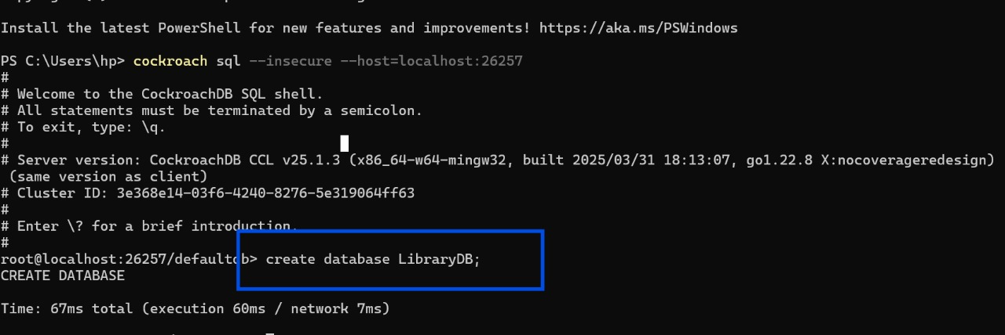

Step 2::

Create a table

PART 1::::

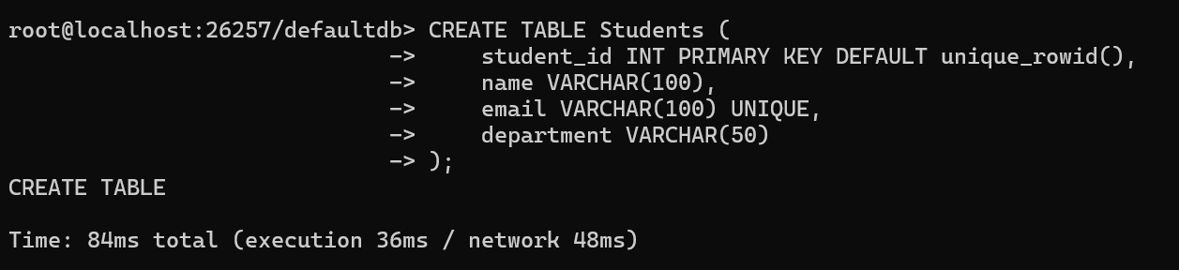

Part 2:::

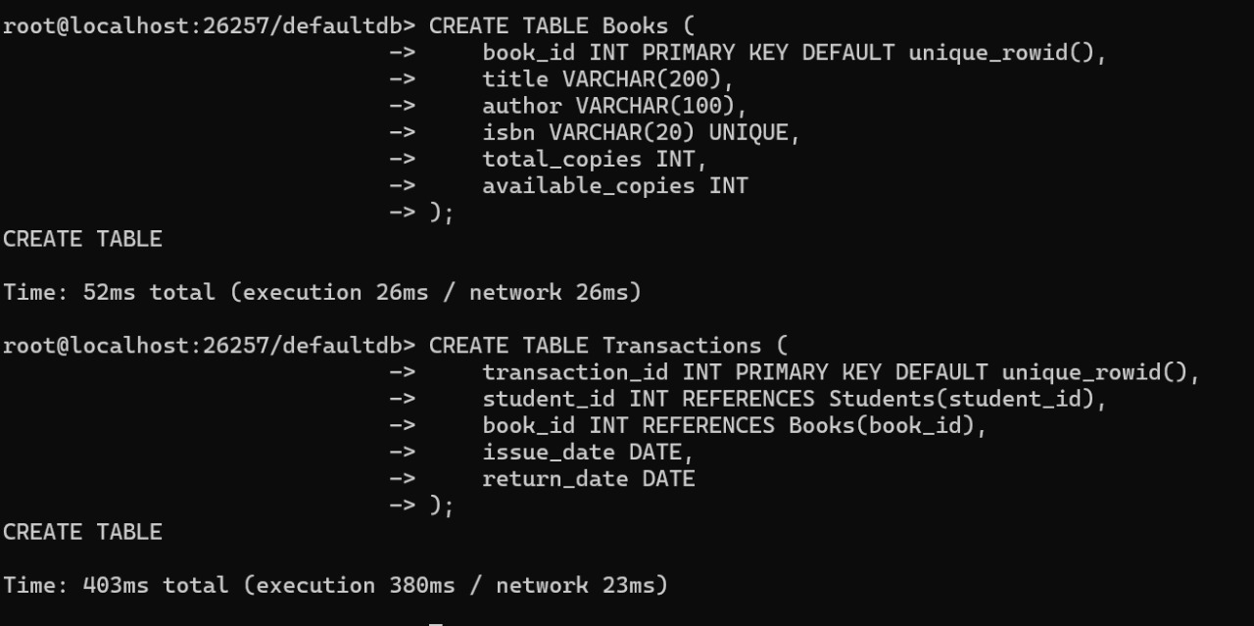

Step 3:

Inserting values in tables

table 1:

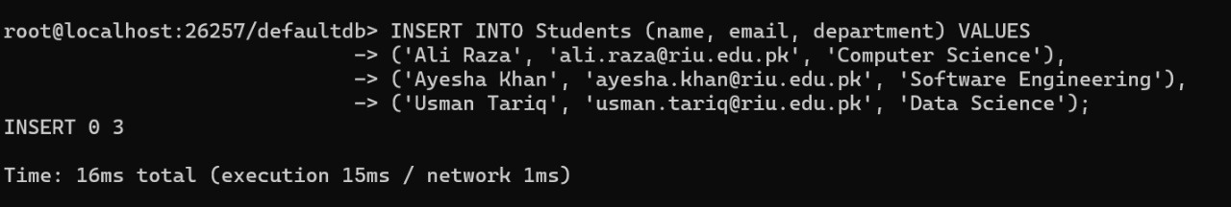

Table 2:

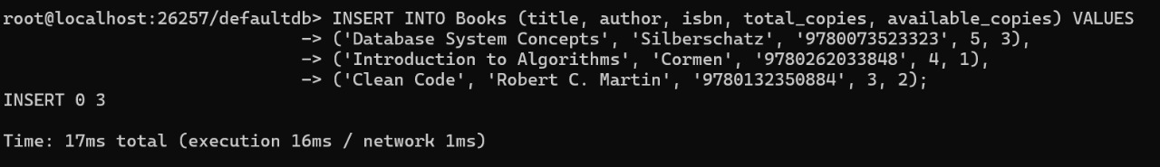

Table 3::

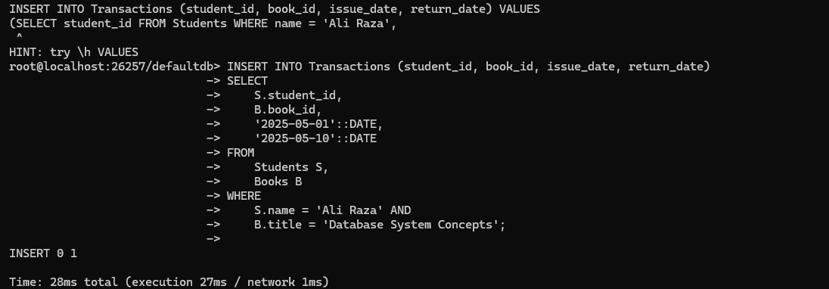

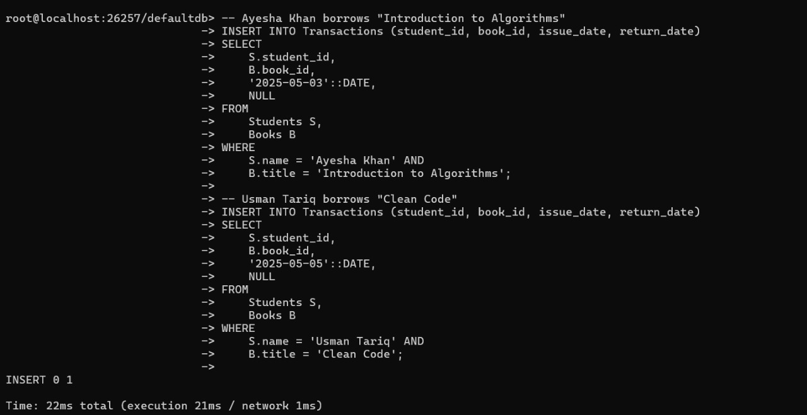

Step 4:

Apply DML quries

Part 1:

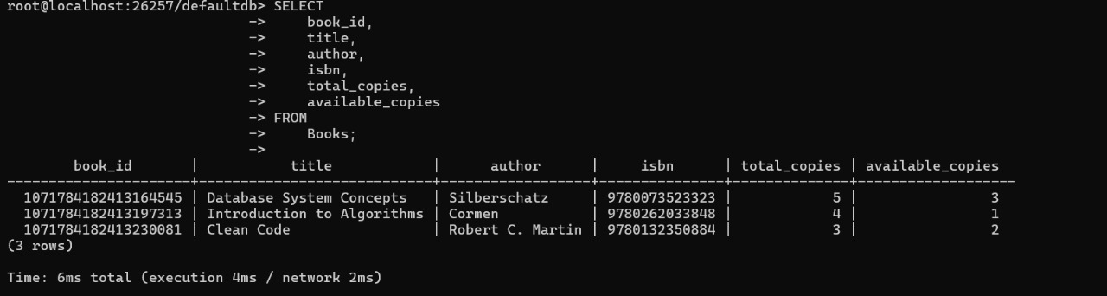

Par t 2:

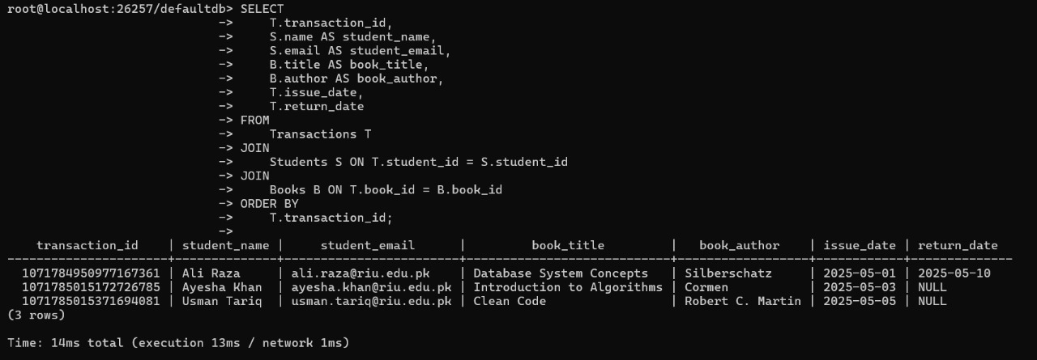

Par t 3:

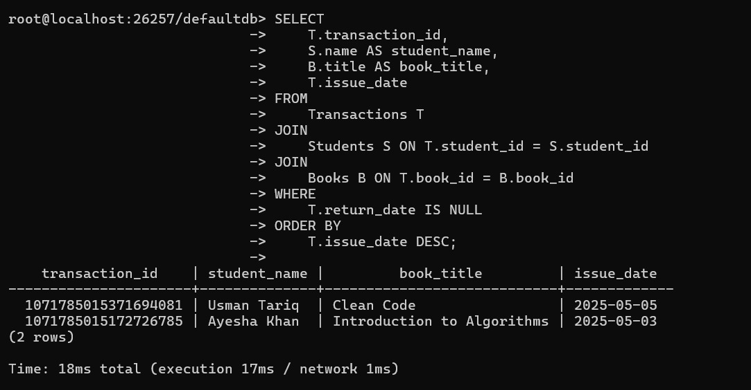

Part 4:

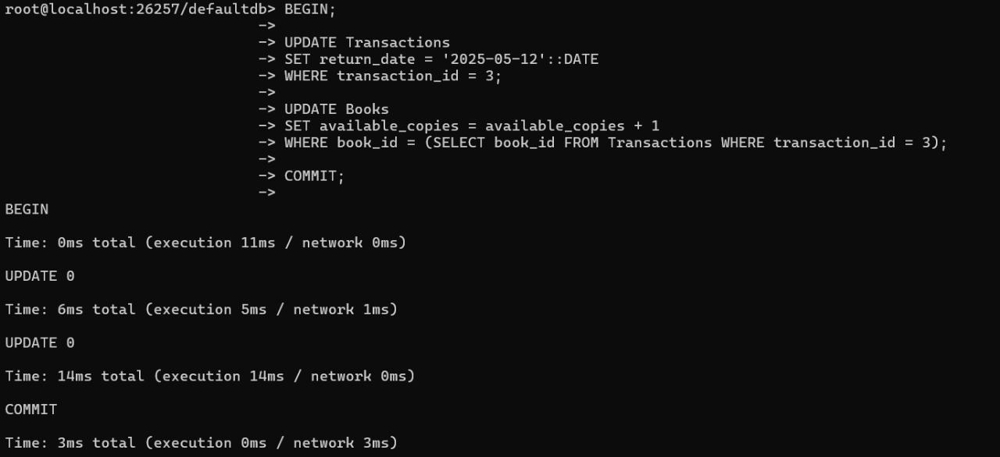

Part 5:

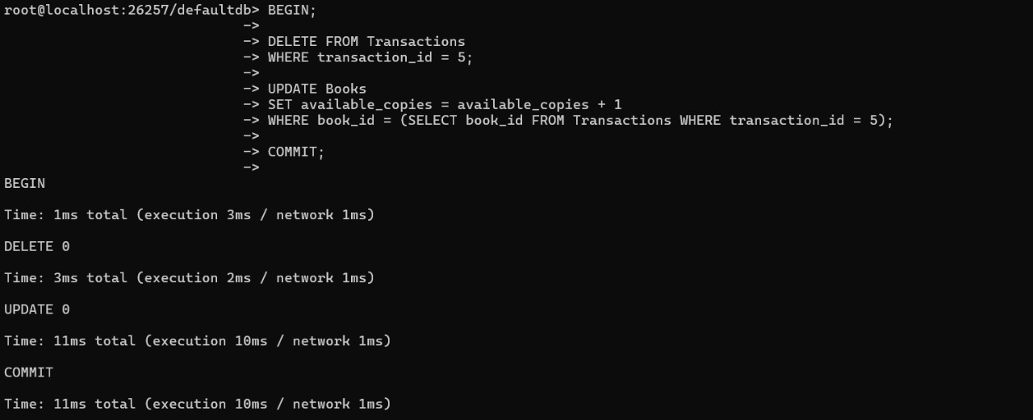

ER DIGRAM :::

